BRAVE BROWSER OPTIMIZATION GUIDE
Guide made by:
Discord: tarik#1326
Twitter: tarekifla

Optimizing settings
Type brave://settings in your search bar. On the left side of your screen, you should see Settings.

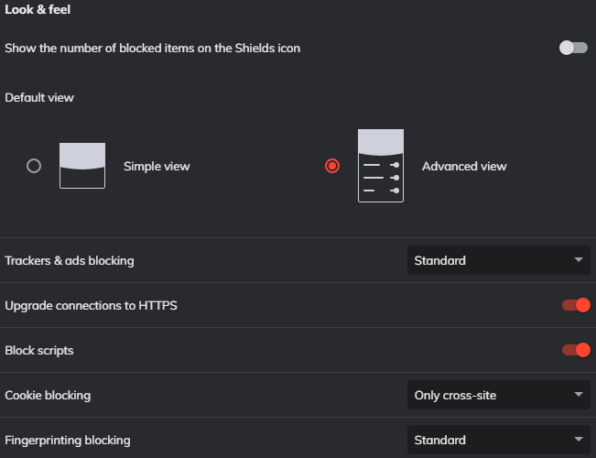
- Click SHIELDS and copy my settings:

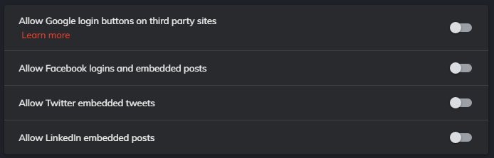
- Click SOCIAL MEDIA BLOCKING and copy my settings:

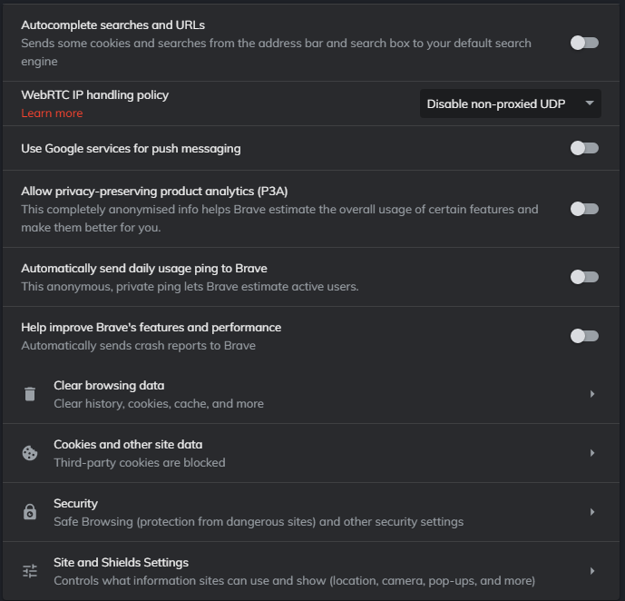
- Click PRIVACY AND SECURITY and copy my settings:

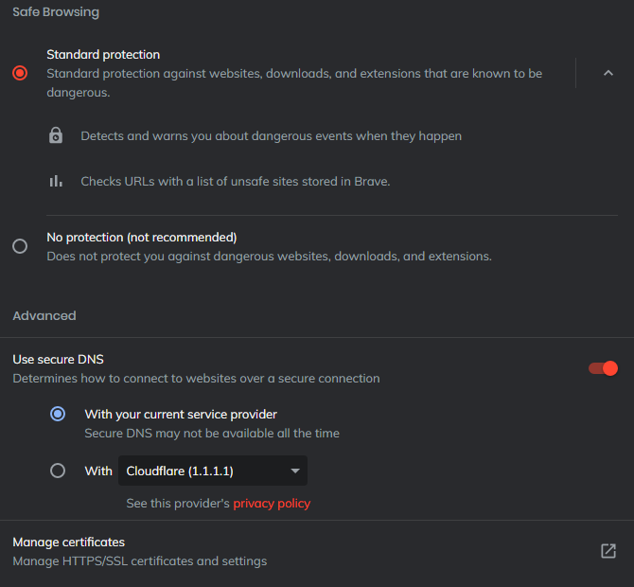
- Under PRIVACY AND SECURITY, on the bottom part you will see SECURITY, click on it and copy my settings:

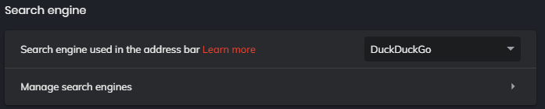
- On the left column click SEARCH ENGINE and copy my settings:

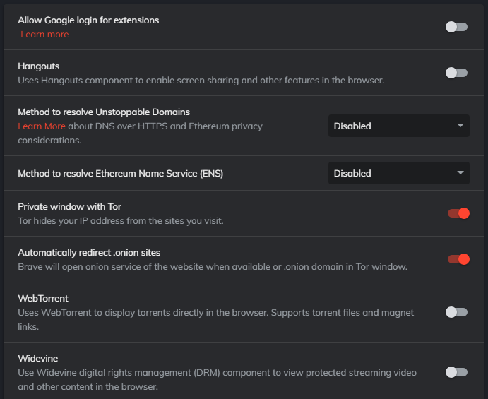
- Click EXTENSIONS and copy my settings:

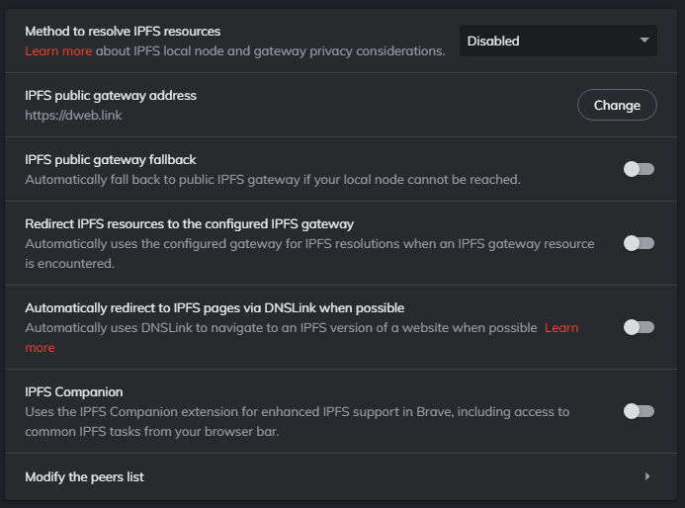
- Click IPFS and copy my settings:

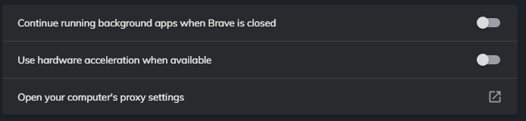
- On the bottom of the SETTINGS column, you will see ADDITIONAL SETTINGS, click that and click SYSTEM, copy my settings:

Optimizing brave://flags
Type brave://flags in your search bar. A page with the title of Experiments should come up. Above the word Experiments is a search bar which says “search flags”. Search every of these flags in that search bar and copy my settings.
Override software rendering list > Enabled
Enable Reader Mode > Disabled
WebRTC remote-bound event logging > Disabled
Smooth Scrolling > Enabled
Experimental QUIC protocol > Enabled
GPU rasterization > Enabled
Parallel downloading > Enabled
Happiness Tracking Surveys for the Privacy Sandbox > Disabled
Happiness Tracking Surveys for Privacy Settings > Disabled
Back-forward cache > Enabled
WinRT Geolocation Implementation > Disabled
Heavy ad privacy mitigations > Enabled
Enable Brave Rewards verbose logging > Disabled
Enable Brave Talk > Disabled
Enable Gemini for Brave Rewards > Disabled
Hardware-accelerated video encode > Disabled
Hardware-accelerated video decode > Disabled
Enable system notifications > Disabled
Search your screen with Google Lens > Disabled

Optimizing startup parameters
On Windows, you right-click the Brave shortcut on your Desktop and select Properties. You will see a TARGET window, at the end of the path put a space and add this:
--process-per-site --enable-low-end-device-mode
--process-per-site - Uses a single process per site, this is useful if you open multiple pages on a single site as it will reduce RAM usage.

--enabled-low-end-device-mode - Enables low end device mode which improves memory consumption

Extensions

DuckDuckGo Privacy Essentials - Blocks trackers, encrypted connections.
DarkReader - Makes everything dark themed.

This guide was composed by Tarik.
Twitter: tarekifla
Discord: tarik#1326

